DEPARTMENT OF HOUSING

PROJECT SIGN – CDBG Funds

8’-0”
4’-0”

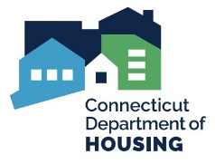
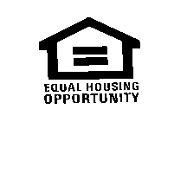

NAME OF GRANTEE
NAME OF CHIEF ELECTED OFFICAL

NAME OF THE PROJECT

Constructed in cooperation with the

STATE OF CONNECTICUT
__ (insert full name) __, GOVERNOR

DEPARTMENT OF HOUSING
__ (insert full name) ___, COMMISSIONER

Additional Funding Agency, (when applicable)
__ (insert full name) ___, Title

Name of Architect/Engineer Name of General Contractor

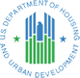
This project is funded by a Community Development Block Grant financed by the U.S. Department of Housing and Urban Development.

SIGN PANEL: ¾” MDO-EXT-APA PLYWOOD SUPPORTED WITH (2) 4X4 TREATED WOOD COLUMNS AND SECURED 4’ INTO GRADE. TOP OF SIGN AT 8’-0” ABOVE GRADE.

COLORS: ALL LETTERS AND SYMBOLS ARE TO BE ROYAL BLUE. THE BACKGROUND WILL BE WHITE ENAMEL. BACK OF PLYWOOD AND SUPPORT STRUCTURE SHALL BE PAINTED MATTE BLACK.

TYPEFACE: HELVETICA MEDIUM

LOCATION: SIGN MUST BE LOCATED TO BE CLEARLY VISIBLE TO THE PUBLIC.

TIMING: INSTALL AT THE START OF CONSTRUCTION AND REMOVE AT CONSTRUCTION COMPLETION.

STATE LOGO: ATTACHED



