Memorandum

To: All DCF Staff

From: Commissioner Vannessa Dorantes

Date: 8/16/2020

Re: Update on Department Operations and Commissioner Weekly Video
____________________________________________________________________________________________________________

Hurricane Isaias has moved on. We hope you and your families are safe with full power and internet services restored. Once again, you have demonstrated strength and resilience as we support one another.

Our virtual work remains impressive. We are appreciating the diligence, creativity, and willingness to do whatever it takes to connect with the children and families we serve. We learn more about how you are keeping our mission critical work going through these 'storms'.
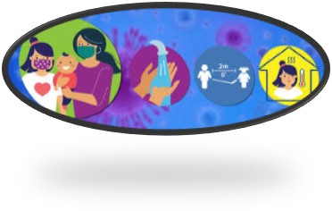
The Department will continue to reactivate additional aspects of our work while balancing the health and safety of our workforce. For example, by the end of August, all remaining cohorts of youth in our care can be included in the in-person visitation triage process. Maintaining connections between parents and children is essential to their emotional well-being.
Every aspect of planning considers the public health crisis we are in.

This week, we use this opportunity to dispel myths about staff physically returning to our offices.
There is a purposeful plan under way. The plan's stages follow the health metrics closely.
We have not set a date for full staff to report in-person to offices:

- There are staff who have not stopped coming into our workspaces at all --- for that we thank you all.
- There are others who have come in certain days while working the other days remotely as the nature of their work requires it.
- We also have individual circumstances where specific staff have been asked to physically report in.

- Lastly, we continue to remind staff who want to come into an office to work, get supplies or use equipment, that this needs to be coordinated and approved thru your supervisor to the leader of that location.

None of those situations has been contrary to ReOpen CT guidelines nor do they represent any large-scale physical reporting in. Engineering has worked diligently to ready all our spaces for safer occupancy. Our central and area offices remain closed to the public.

Until we can all be together physically again, whenever leaving your home for work activity please remain vigilant in safety protocols. Continue to keep yourself, your family, the public we serve and your coworkers in mind as we navigate this pandemic cautiously.

This being said, it is important staff concurrently plan for your own individual needs.
The attached COVID-19 FAQ guidance has been routinely updated by the Department of Administrative Services (DAS). Questions regarding healthcare, eldercare, and childcare along with other considerations are answered in that document. The manner we conduct our work has changed and will continue to evolve. This is the time you plan for your short- and long-term future. We are fortunate to have had the privilege of authorizing telework thus far. By following this guidance, you can balance getting your work done in the remote environment as long as we have it available.
Watch for information this week on preparing children and their caregivers for a return to school whenever and in whatever form that takes.

Mark your calendars……
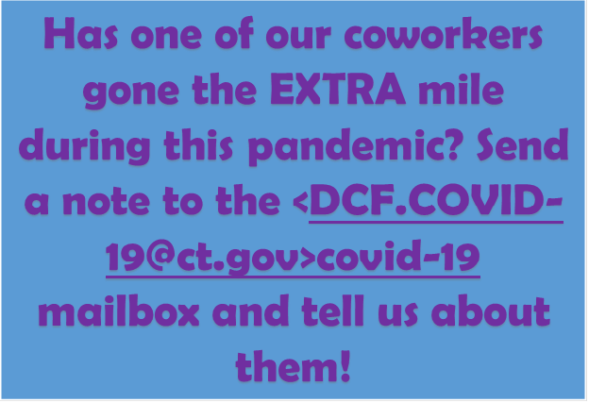
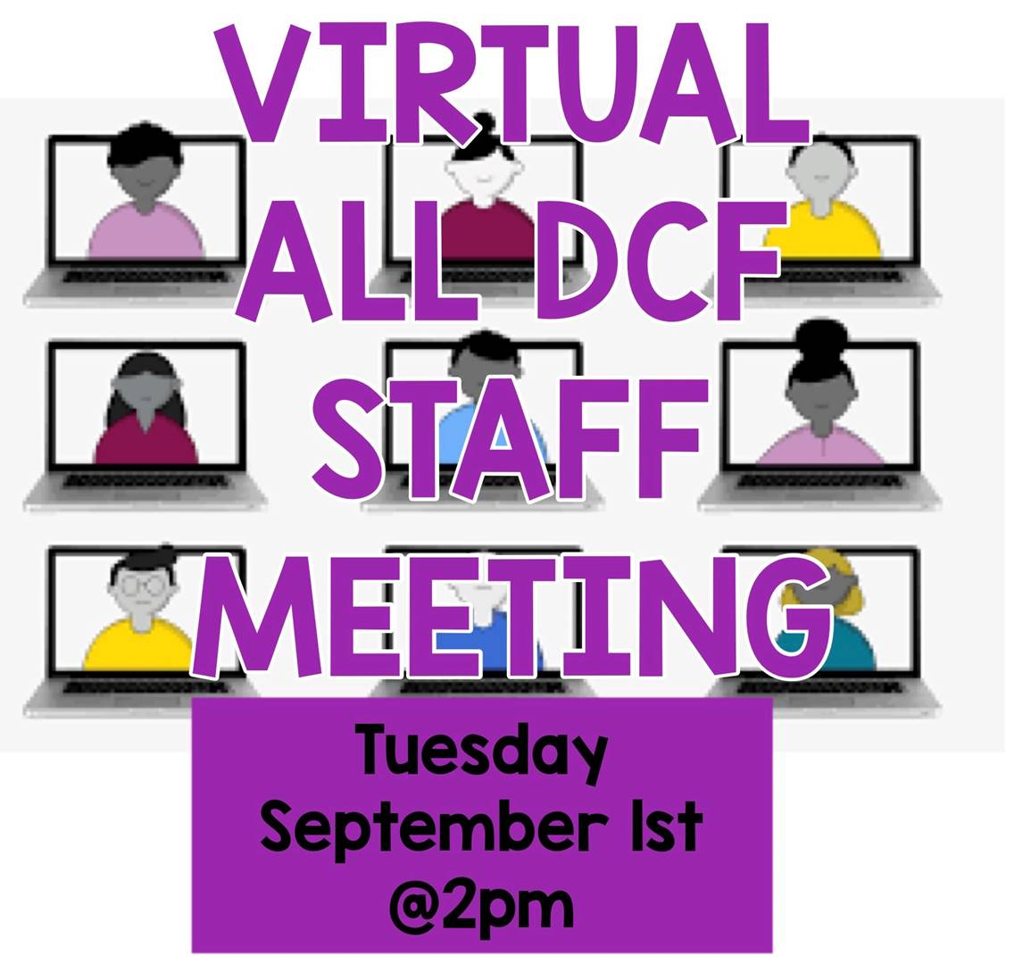

We are also resuming our Listening Tour -- this time virtually -- picking up where we were interrupted in the spring for our central office divisions, facilities and regional offices.
This will be another opportunity to hear directly from YOU!!!

Click here to view this week's video for additional updates => Commissioner's Weekly Video 8-16-20

Stay safe, stay healthy and stay DCF STRONG.


VANNESSA L. DORANTES, LMSW
COMMISSIONER
CT DEPT OF CHILDREN & FAMILIES
505 HUDSON STREET
HARTFORD, CT 06106

commissioner.dcf@ct.gov (860)550-6300
" I do my best because I'm counting on YOU counting on me…"
m angelou

