Activity 3.5.6b Rectangles and Rhombuses

A rectangle is defined as an equiangular quadrilateral and a rhombus is defined as an equilateral quadrilateral. In this investigation, you will prove necessary and sufficient conditions for rectangles and rhombuses.
Review of Necessary Conditions of Rectangles and Rhombuses
1. If a quadrilateral is a rectangle, then the diagonals are ____________________________.
2. If a quadrilateral is a rhombus, then the diagonals are ____________________________.
Before we prove these conjectures, we need to prove that all rectangles are parallelograms and all rhombuses are parallelograms.
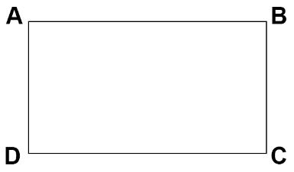
3. Prove that All Rectangles are Parallelograms
Given: ABCD is a rectangle.
Prove: ABCD is a parallelogram.

Since ABCD is a rectangle, $m∠A=m∠B=m∠C=m∠D$
This means that pairs of opposite angles are congruent: , $m∠A= ______$and $m∠B=______$
In Activity 3.5.5 we proved that If a quadrilateral has two pairs of opposite angles that are _______________, then the quadrilateral is a parallelogram. Since ABCD has two pairs of opposite angles congruent, it must be a _____________________.
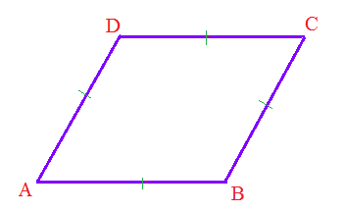
4. Prove that All Rhombuses are Parallelograms.
Given: ABCD is a rhombus.
Prove: ABCD is a parallelogram.

Use the previous proof as a guide.

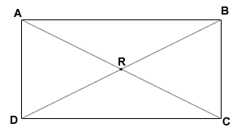
5. Prove Rectangle Diagonals Theorem: If a parallelogram is a rectangle, then the diagonals are congruent.

Given: ABCD is a rectangle.

Prove: $\overline{AC}≅\overline{BD}$

First, develop a plan for your proof by thinking backwards.

a) Name two triangles that you can prove are congruent that have the diagonals as corresponding parts. Hint: They may be overlapping triangles.

b) What three parts of those triangles can you prove are congruent?

Fill in the blanks in the proof below.

Since ABCD is a rectangle, opposite sides are ___________________. Therefore, ________$≅$_________. It is also true that ________$≅$_________ because it is a shared side. By definition of rectangle, $∠$_________$≅∠$_________. By SAS, $Δ$___________$≅ Δ$___________.
$\overline{AC}≅\overline{BD}$ by ___________________.

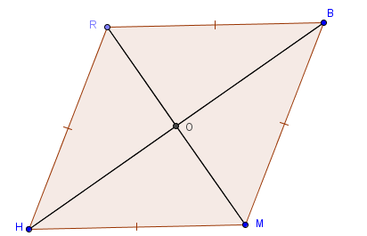
6. Prove Rhombus Diagonals Theorem: If a parallelogram is a rhombus, then the diagonals are perpendicular.

Given: RBMH is a rhombus.

Prove: $\overline{RM}⊥\overline{BH}$

Plan for Proof: Choose any pair of small triangles that share a side. Use parallelogram diagonals theorem to help you prove that they are congruent. What corresponding parts would make the diagonals perpendicular?

Write the proof.

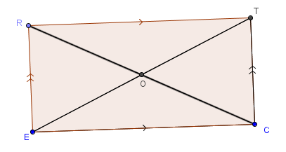
7. Prove Rectangle Diagonals Converse: If the diagonals of a parallelogram are congruent, then the parallelogram is a rectangle.

Given: RTCE is a parallelogram.
$\overline{RC}≅\overline{TE}$

Prove: RTCE is a rectangle.

Since RTCE is a parallelogram, opposite sides are ________________, so $\overline{RE}≅\overline{TC}$. $\overline{EC}≅\overline{EC}$ because _________________. Since it is also given than $________≅________$, by __________ triangle congruence, it follows that $Δ$___________$≅ Δ$___________. By CPCTC, $∠REC≅____________$. Since it has been proven that opposite angles of a parallelogram are _______________, then all four angles are __________________. Then by definition of _________________, ______________________.

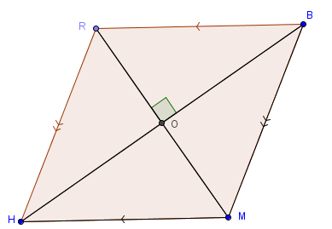
8. Prove Rhombus Diagonals Converse: If the diagonals of a parallelogram are perpendicular, then the parallelogram is a rhombus.

Given: RBMH is a parallelogram.
$\overline{RM}⊥\overline{BH}$
Prove: RBMH is a rhombus.

Plan: Use the parallelogram diagonals theorem to find congruent segments. Explain why all four small triangles are congruent in the figure. Then, explain how that proves the figure is a rhombus.
Write the proof.

