Activity 3.4.4 Constructing Regular Polygons with Compass and Straightedge

Some regular polygons may be constructed with compass and straightedge. Use these tools or software to perform these constructions. If you use software be sure to use only the straight object and circle tools.

- Regular Triangle (also known as an equilateral triangle). You already did this in Activity 2.6.2 and wrote a proof in Activity 2.7.1.
- Regular Quadrilateral (also known as a square). You may have done this in Activity 2.6.3. If not, let’s try it here.
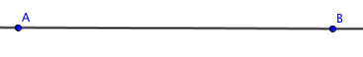
- Start with a line through two points A and B. $\overline{AB}$ will be one side of the square

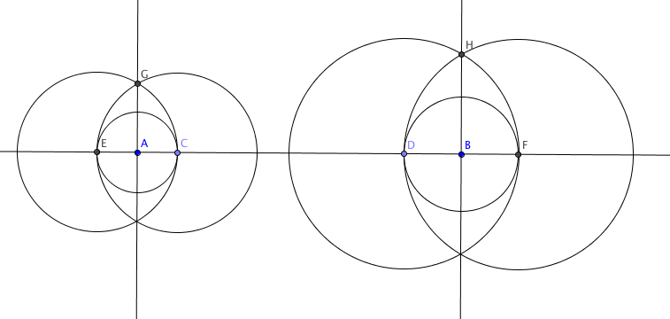
- Construct lines $\overset{⃡}{AG}$ and $\overset{⃡}{BH}$ perpendicular to $\overset{⃡}{AB}$. You did this in Activity 2.7.3. You may want to review the activity or study the figure below.

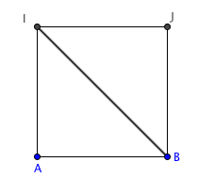
- Locate point I on ray $\vec{AG}$ so that AI = AB. Construct a line through I perpendicular to $\vec{AG}$ and let this line intersect $\overset{⃡}{BH}$ at point J. In the space below, prove that quadrilateral ABJI is a square. (Hint: First show that m $∠$ BJI = 90°. Then show that ∆IAB $≅$ ∆IJB.)

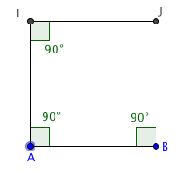

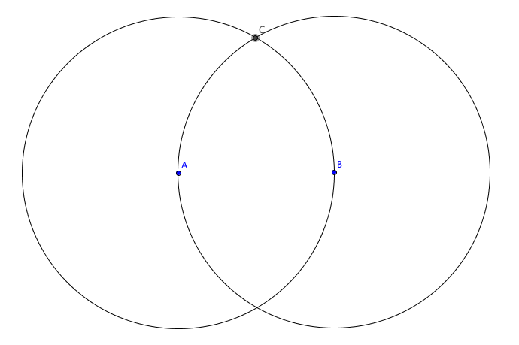
- Regular Pentagon. This construction uses the Golden Ratio and will be presented in Unit 8 Investigation 3.
- Regular Hexagon.
- Start with points A and B. Draw a circle with center A passing through B and a circle with center B passing through A. Label one of the points where the two circles intersect point C.

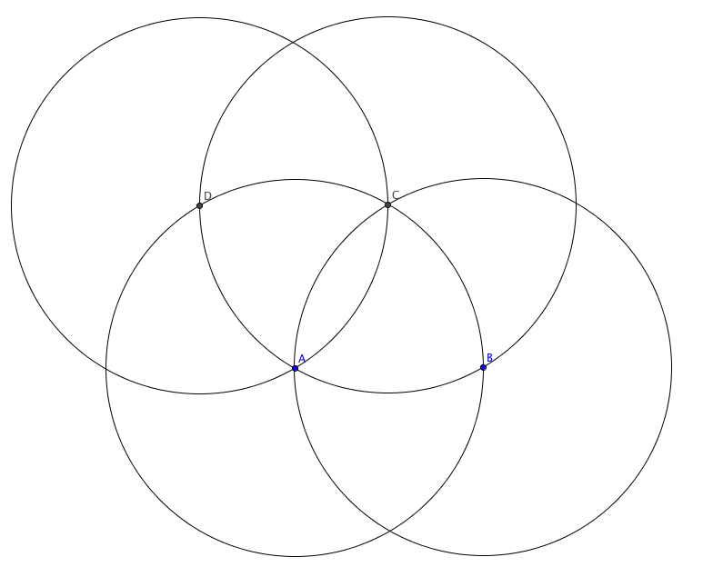
- Draw a circle with center C passing through A. Label D the point where this circle intersects circle A.
- Continue the process with a circle centered at D passing through A to locate point E. And then a circle with center at E and another one with center at F.
- You should end up with 6 points on circle A evenly spaced. Join B to C to D to E to F to G to B to form a hexagon.
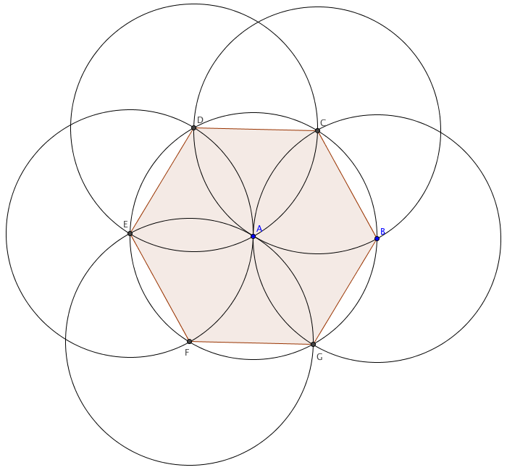
- In the space below, prove that hexagon BCDEFG is regular. First show that all six sides are congruent and then show that all 6 angles measure 120°

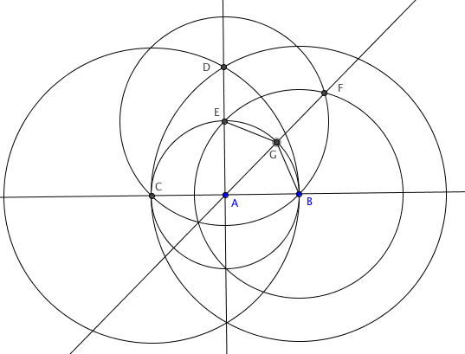

- Regular Heptagon. Sorry, it is impossible to construct a regular polygon with 7 sides using only compass and straightedge!
- Regular Octagon. If you like an extra challenge, try this one. Hint: The figure at the right shows how you might get started.

