Activity 3.4.1 Exterior Angles of a Polygon

Sum of Exterior Angles of a Polygon Conjecture: The sum of the exterior angles (one at each vertex) for any convex polygon is _______________.

Measure the exterior angles (one at each vertex) for each of the convex polygons. Record your answers in the appropriate spaces below.

Triangle  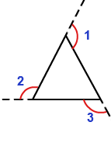  Measure of Exterior Angle 1: ___________  Measure of Exterior Angle 2: ___________  Measure of Exterior Angle 3: ___________  Sum of Exterior Angles: _______________ | Quadrilateral  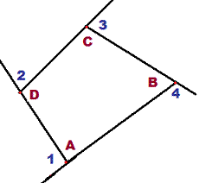  Measure of Exterior Angle 1: ___________  Measure of Exterior Angle 2: ___________  Measure of Exterior Angle 3: ___________  Measure of Exterior Angle 4: ___________  Sum of Exterior Angles: _______________
Pentagon  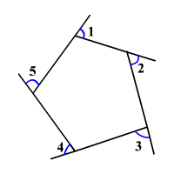  Measure of Exterior Angle 1: ___________  Measure of Exterior Angle 2: ___________  Measure of Exterior Angle 3: ___________  Measure of Exterior Angle 4: ___________  Measure of Exterior Angle 5: ___________  Sum of Exterior Angles: _______________ | Hexagon  Draw a hexagon using your ruler. Measure the six exterior angles of your hexagon.  Measure of Exterior Angle 1: ___________  Measure of Exterior Angle 2: ___________  Measure of Exterior Angle 3: ___________  Measure of Exterior Angle 4: ___________  Measure of Exterior Angle 5: ___________  Measure of Exterior Angle 6: ___________  Sum of Exterior Angles: _______________
Compare your exterior angle sum with another student. Is their sum the same? Is this surprising?

Your exterior angle sum: ______________

Student __________ (name) exterior angle sum: ____________

What conclusions can you make? Do you think this works for any polygon? Write down some of your thoughts. Discuss this with your partner and write your combined thoughts in the space provided.

Notice: It is possible to draw two (equal) exterior angles at each vertex of a polygon. Either ∠1 or ∠2 below are exterior angles. ∠3 is not considered an exterior angle. The sum of the exterior angles formula uses only ONE exterior angle at each vertex. The exterior angle and the adjacent interior angle form a linear pair (are supplementary).
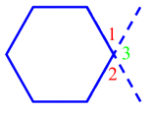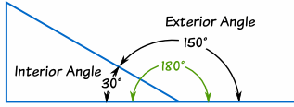

Review your conjecture:
Sum of Exterior Angles of a Polygon Conjecture: The sum of the exterior angles (one at each vertex) for any convex polygon is _______________.

What is the sum of the exterior angle measures, one at each vertex, of each polygon?
- Pentagon (5-sided polygon) _________________
- Heptagon (7-sided polygon) _________________
- Decagon (10-sided polygon) _________________

- _________________

- _________________

At each vertex of a polygon there can be drawn an exterior angle, which is supplementary to the adjacent interior angle at the vertex.

Complete the table below:

Convex Polygon | Number of vertices | Diagram of interior and exterior angle pairs at each vertex | Sum of all interior and exterior angle pairs at each vertex
Triangle | 3 | 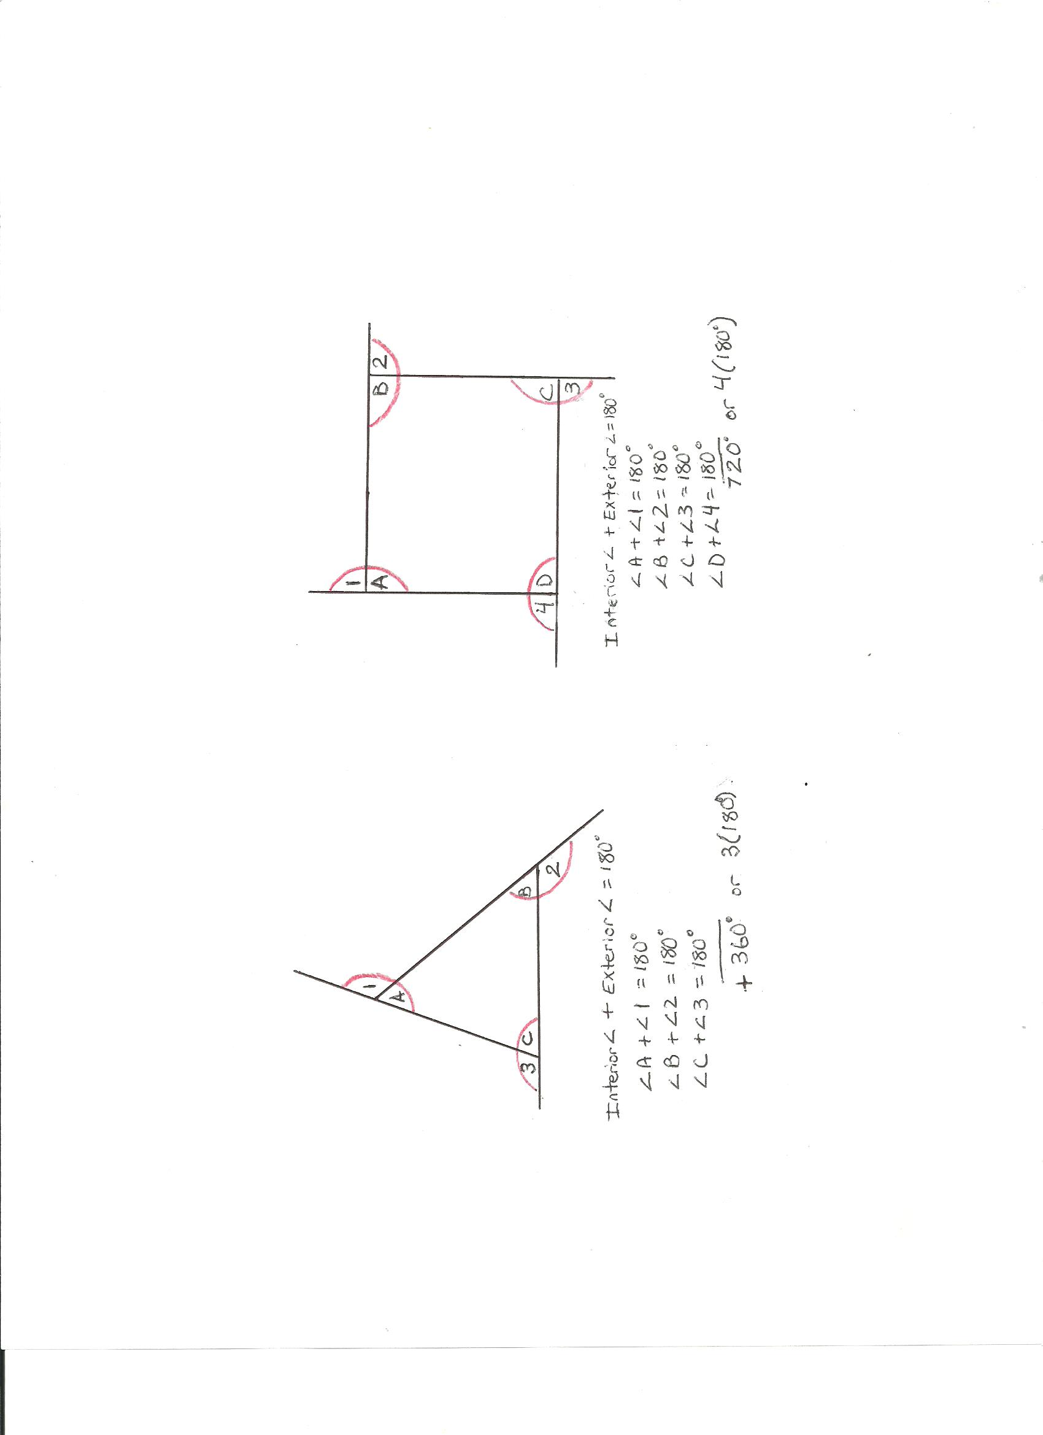 | 3(180°)  or 540°
Quadrilateral |  |  | 4(180°)  or
Pentagon |  |  | 5(180°)  or
n-gon | n |  | n(180°)

The sum of all interior and exterior angle pairs at each vertex of a polygon is ________.

In Unit 3- Investigation 1, you learned about the sum of interior angles of polygons.

Triangle Sum Theorem: In any triangle the sum of the interior angles is 180°.
Quadrilateral Sum Theorem: In any convex quadrilateral the sum of the interior angles is 360°.
Polygon Sum Theorem: In any convex polygon with n sides, the sum of the interior angles is 180°(n – 2).

Complete the table below:
Convex Polygon | Number of sides | Diagram of interior angles | Sum of interior angles
Triangle
Quadrilateral |  |  | (4–2)180° = 360°
Pentagon
n-gon | n | (n–2) 180°

Complete the Algebraic Proof:

The sum of all interior and exterior angle pairs at each vertex of a polygon is _________.
By the Polygon sum theorem, the sum of interior angles of a polygon is _________.
Next, take the sum of all the interior and exterior angle pairs at each vertex of a polygon and subtract the sum of interior angles of a polygon, to get the sum of exterior angles of a polygon.
Then the sum of the exterior angles is _______– _________.
Simplified this is: 180°n – 180°n + 360° = 180°n – 180°n + 360° = __________ .
Therefore the sum of exterior angles of a polygon is 360°.

