Activity 3.1.5 Applications of the Triangle, Quadrilateral and
Polygon Angle Sum Theorems

Part I -- Triangles

Determine the missing degree measure for each diagram. m $∠B$

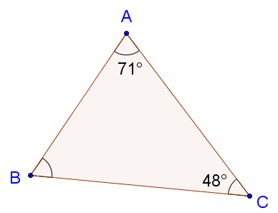

- m $∠B$ = _______

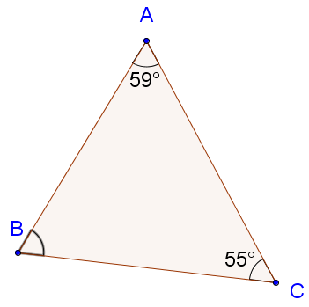

- m $∠B$ = _______

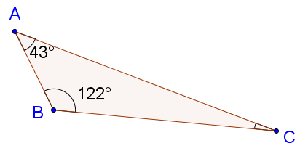

- m $∠C$ = _______

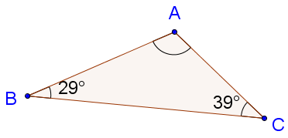

- m $∠A$ = _______

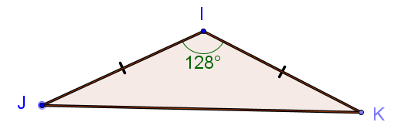

- m $∠J$ = _______

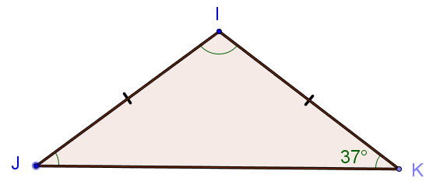

- m $∠I$ = _______

Use the diagram at the right for questions 7 and 8.

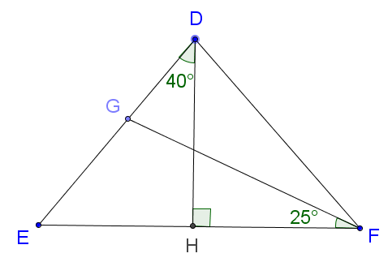
- m $∠GEH$ = _______

- m $∠DGF$ = _______

- Use the diagram below to determine the measures of the angles.

m $∠1$= _______

m $∠2$ = _______

m $∠3$ = _______

m $∠4$ = _______

m $∠5$ = _______

m $∠6$ = _______

m $∠7$ = _______

m $∠8$ = _______

m $∠9$ = _______

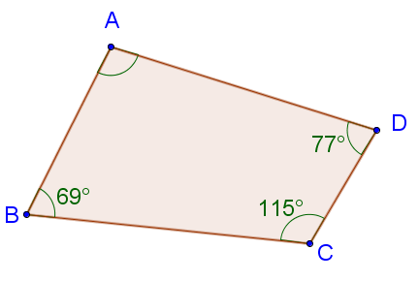
Part II -- Quadrilaterals and Other Polygons

- Determine the measure of $∠A$.

m $∠A$ = _______

- Determine the value of x. Then determine the measures of all of the angles in the figure.
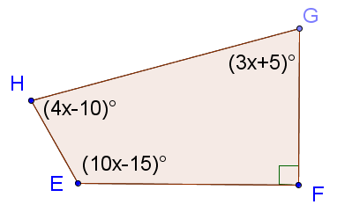

x = _______

m $∠E$ = _______

m $∠F$ = _______

m $∠G$ = _______

m $∠H$ = _______

- Determine the measure of $∠E$.
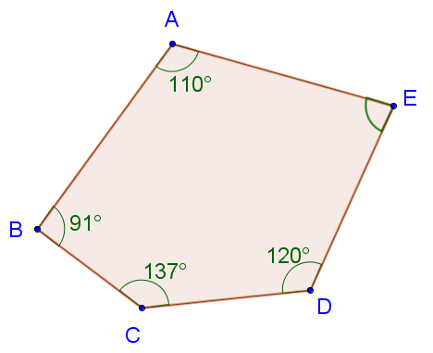
m $∠E$ = _______

- Determine the value of x. Then determine the measures of all of the angles in the figure.

x = _______
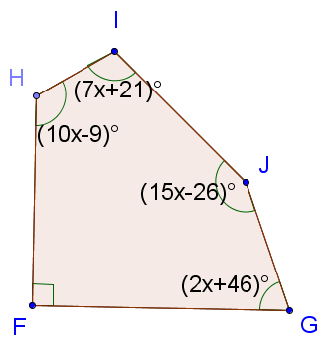
m $∠F$ = _______

m $∠G$ = _______

m $∠H$ = _______

m $∠I$ = _______

m $∠J$ = _______

