Activity 1.5.1 Composing Composite Functions
Suppose that we have two functions f(x) and g(x). The composite function (f $∘$ g)(x) (also written as f(g(x)) is a function whose values are found by applying g to the independent variable x first, then applying the second function f to the value of g(x). In other words (and in color), to find (f $∘$ g)(x), we first find the value of g(x), then find the value of f(g(x)).

- This problem explores the composition of two functions, $f(x)=2x-3$ and $g(x)=x^{2}$.

$$x$$ | $$f(x)=2x-3$$ | $$g(x)=x^{2}$$ | $$f∘g$$ | $$g∘f$$
-3 | -9 | 9
-2 | -7 | 4
-1 | -5 | 1
0 | -3 | 0
1 | -1 | 1
2 | 1 | 4
3 | 3 | 9

- Complete the fourth column by finding f $∘$ g.
- Sketch the graphs of f(x), g(x), and (f $∘$ g)(x) on the same coordinate axes. Use an appropriate scale for the graph.
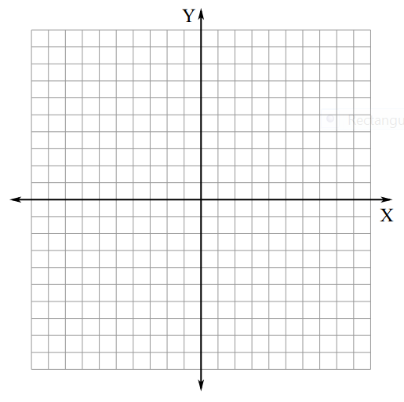

- Can you tell what kind of a function f $∘$ g is? Explain.

- Complete the last column in the table above by finding g $∘$ f.

- Sketch the graphs of f(x), g(x), and g $∘$ f on the same coordinate axes. Use an appropriate scale for your graphs.

- Can you tell what kind of a function g $∘$ f is?

- Are f $∘$ g and g $∘$ f the same function? Are they the same type of function?

- a) Given the graphs of f(x) and g(x) below, sketch the graph of (f $∘$ g)(x) on the same coordinate plane. (Hint: Think about what happens when x = -3, x = -2, etc. For example, what is f(g(-3))? Consider making a table of values first.)
b) Can you tell what kind of function f $∘$ g is? Explain.

3) Given f(x) and g(x) on the table below, fill in the remaining columns by finding f $∘$ g, g $∘$ f, f $∘$ f, and g $∘$ g. Are any of these functions the same for any values of x?

$$x$$ | $$f\left(x\right)= 3x-2$$ | $$g(x) = x^{2}-1$$ | $$f∘g$$ | $$g∘f$$ | $$f∘f$$ | $$g∘g$$
-4
-3
-2
-1
0
1
2
3
4

