Activity 3.5.1 Technology Companies - Can You Count on Them?

The profit (in billions of dollars) for the software company, Electronic Arts, Inc., from the year 1998 to the year 2004, where t=0 is the year 1998, is given in the table below.
Years Since the End of Fiscal Year 1998 | Net Revenues  in Billions of Dollars
0 | .909
1 | 1.222
2 | 1.420
3 | 1.322
4 | 1.725
5 | 2.482
Data Source: Electronic Arts, Inc., Annual Reports, March 31, 2002 and 2004

Answer the questions below in the space provided.

1. Create a scatter plot for the data in the table in the grid to the right.  2. Based on the scatter plot, what degree polynomial would best fit the data? Explain your answer.  . | 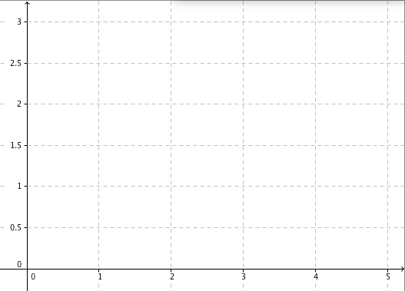

3. Enter the data in lists L1 and L2 on a TI 83/84 graphing calculator in order to determine a regression function to model the revenue as a function of time.

4. Go to the STAT CALC menu of the calculator and select the regression function for the function you identified in #2 to find the polynomial function that best fits the data.

Use the regression model to answer the following questions.
5. During what period or periods of time was the revenue of the software company increasing? When was the profit decreasing?

6. What happened in the year 2001 that could have caused the revenue to decrease?

7. Use the model to estimate during what year would the profits surpass $4 billon?

8. Check profits for EA during the year you predicted the revenue to reach $4 billon and determine whether or not the model is accurate for long-range planning. Explain your answer.

