Activity 2.5.4 Parallel Lines and Corresponding Angles

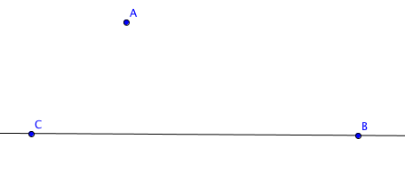
- Open the file Activity_2_5_4_file.gbb. You will find $\overset{⃡}{BC}$ with point A not on $\overset{⃡}{BC}$ as shown.


- Use the parallel line tool to draw a line through A parallel to $\overset{⃡}{BC}$.

- Use the line tool to draw a transversal to the two parallel lines through A and C.
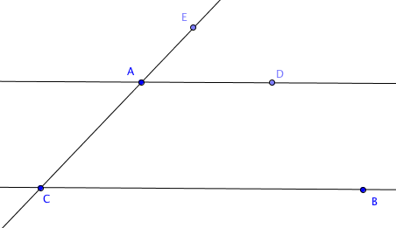

- Use the point-on-object tool to create point D on the line parallel to $\overset{⃡}{BC}$ and point E on line $\overset{⃡}{AC}$.
- Measure $∠$BCA and $∠$DAE. What do you notice?

- $∠$BCA and $∠$DAE are called _________________ angles.


- Use the translate tool to translate $\overset{⃡}{BC}$ by the vector from C to A. Follow these steps.

- First select the line $\overset{⃡}{BC}.$ Then select points C and A (in that order) to create the vector. You should now see the image of $\overset{⃡}{BC}$ highlighted and the vector should appear as an arrow.
- You will now translate individual points. With the translate tool select point A and then the vector. Then select point B and the vector. Finally select point C and the vector.

- Describe the positions of points A’, B’, and C’.

- $∠$B’C’A’ is another name for which angle?

- How do you know that m$∠$BCA = m$∠$B’C’A’?

- Study this proof of the Parallel Lines Corresponding Angles Theorem and discuss it with your classmates.

Parallel Lines Corresponding Angles Theorem

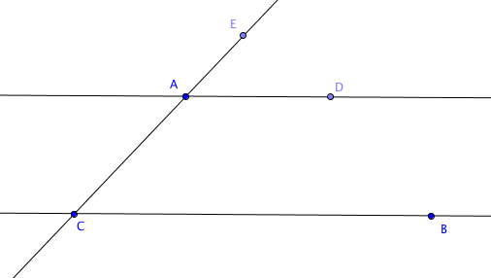
If two parallel lines are cut by a transversal, then pairs of corresponding angles are congruent.

Given:$\overset{⃡}{ AD}∥\overset{⃡}{CB}$.

Prove: $∠BCA ≅ ∠DAE$

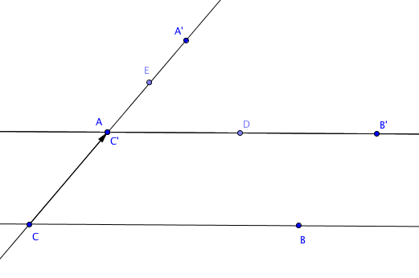
Proof:

Translate $∠BCA$ by the vector from C to A.

Then C’ coincides with A and A’ lies on $\overset{⃡}{ AC}$,
by special property (a) of translation: the line containing the translation vector and any line parallel to the vector is mapped onto itself.

Also $\overset{⃡}{ C'B'}∥\overset{⃡}{CB}$ by special property (b) of translation: a line not containing the translation vector is mapped onto a line parallel to itself.

By the Parallel Postulate there is exactly one line through A that is parallel to $\overset{⃡}{ CB}$. Therefore $\overset{⃡}{ C'B'}$ and $\overset{⃡}{AD}$ coincide. This means that $∠B'C'A'$ coincides with $∠DAE$so they are names for the same angle. Because $∠B'C'A'$ is the image of $∠BCA$under an isometry, $∠BCA ≅ ∠B'C'A'$. Therefore $∠BCA ≅ ∠DAE.$

12. Why is the Parallel Postulate needed to complete this proof?

