Activity 1.3.4 Rotations in the Coordinate Plane

Open Geogebra. In the Graphics view, make sure the coordinate axes is on. If not, click on the  icon.

Create a point A somewhere in the 1st Quadrant.

1. What are the coordinates of the point you created? ________

Now create a second point B at the origin.
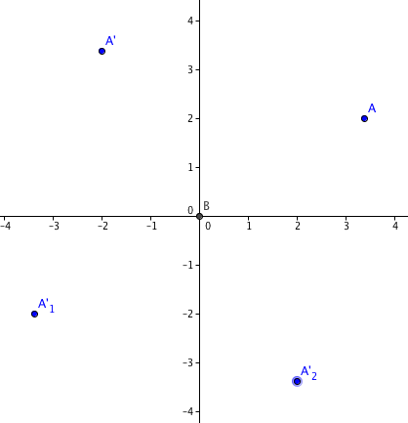
Click on Rotate about Point  and select your first point and then the origin. A box will pop up asking what size angle. Type in 90° (counter-clockwise) and hit enter.

2. What quadrant is the rotated point in? _______

3. What are the coordinates of the rotated point? _________

4. Explain the relationship between your original point and the rotated point

Now, click on Rotate about Point again, and select your original point and then the origin again. This time when the box pops up, type in 180°(counter-clockwise).

5. What quadrant is the rotated point in? _______

6. What are the coordinates of the rotated point? _________

7. Explain the relationship between your original point and the rotated point:

Click on Rotate about Point again, and select your original point and then the origin again. This time when the box pops up, type in 270°(counter-clockwise).

8. What quadrant is the rotated point in? _______

9. What are the coordinates of the rotated point? _________

10. Explain the relationship between your original point and the rotated point:

This time click on Rotate about Point and check the clockwise button. Select your original point and then the origin again. This time when the box pops up, type in 90°(clockwise).

11. What do you notice?

12. Click the move  icon and then click and drag point A. As the coordinates of point A change, what do you notice about the reflected points? Do you see the same behavior as you did before?

13. Suppose we start with the point (–3,5), predict what the coordinates would be of the rotated point after

- 90° counter-clockwise rotation.
- 90° clockwise rotation.
- 270° counter-clockwise rotation.
- 270° clockwise rotation.
14. Suppose we want to rotate a point by 180°. Will it make any difference if the rotation is clockwise or counter-clockwise? Explain.

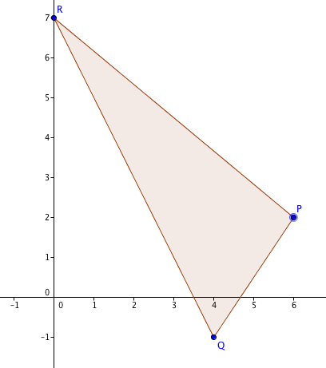
15. In Investigation 2 you learned about mapping rules for translations. Rotations about the origin also have mapping rules. Describe each of these rotations:
a. (x, y) (–y, x)
b. (x, y) (y, –x)
c. (x, y) (–x, –y)

16. Suppose P(6,2) , Q (4, – 1), and R(0, 7) are the vertices of a triangle. Find the image of this triangle when it is rotated 270° about the origin in the counter-clockwise direction.

